11/3/2020

**Skin Cancer Detection**

(Melanoma)

**Name of Student:** N. I. Md. Ashafuddula

**Roll:** **18204016**

**Program: M. Sc. Engineering in CSE Program**

**Course:** CSE-6102

**Course Title:** Advanced Image Processing

**INTRODUCTION:**

Melanoma is a one kind of skin cancer and it is the most dangerous one beacause of increasing percentage rate of death by melanoma skin cancer. Melanoma comes from melanocyte cells, melanin producing cells which generally results black or brown color. Melanomas are mostly caused by exposer to UV rays that damages the DNA of skin cells. In the US alone, more than 1M American will be diagnosed in 20017 with non-melanoma skin cancer, and 59,940 will be diagnosed with melanoma according to American Cancer Society (ACS). Frotunately Skin cancer are rare in Children. Skin Cancer Detection System is the system to identify and recognize skin cancer symptoms and diagnose melanoma in early stages.

**MOTIVATION:**

The diagnoses of melanoma skin cancer detection usually performed by specialized doctors manually. Where the problem of manual detection of melanoma skin cancer is human subjectivity. Which makes it inconsistent in certain conditions.

Therefore, if we could build a computer assisted technology that can help to classify the results of dermoscopy examination and to improve the detection results of melanoma skin cancer with relatively faster time that can save lot of lives.

**OBJECTIVE:**

Our objective is to detect melanoma skin-cancer using CNN to help doctors to identify melanoma skin cancer quickly & efficiently.

**SKIN-CANCER (MELANOMA) FEATURES & PROBLEM DESCRIPTION:**

1. Melanoma comes from melanocyte cells, melanin-producing cells that are usually present in the skin. Because most melanoma cells still produce melanin, melanoma is often brown or black. Fig: a shows the form of melanoma skin cancer.

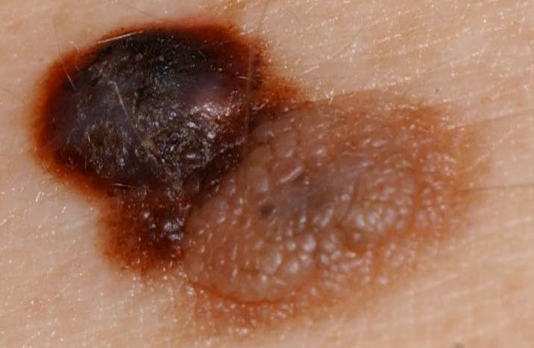 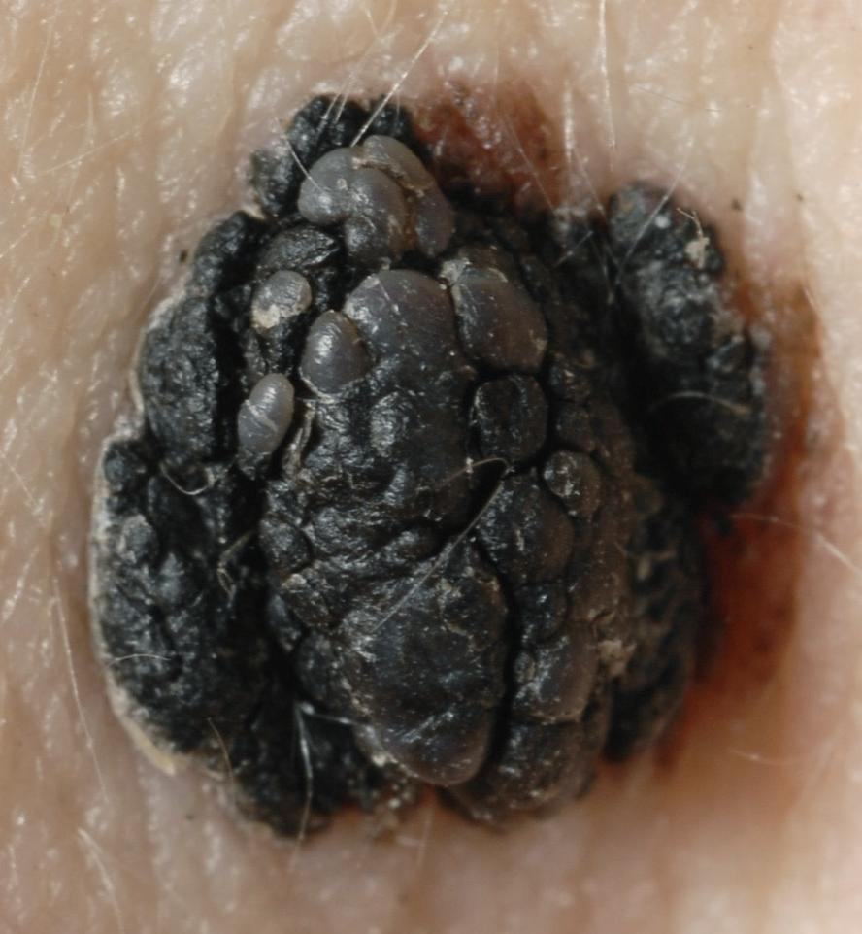 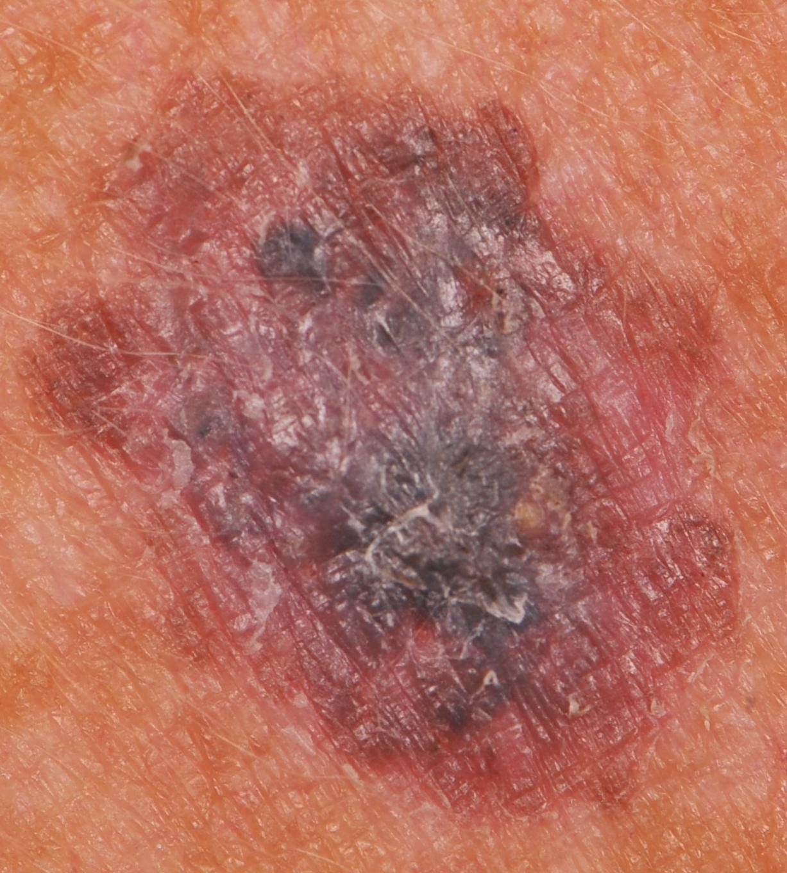

**Fig (a): Dermoscopy Images of Melanoma Cancer.**

1. Melanoma can appear on normal skin, or can appear as a mole or other area of the skin that undergoes changes. Few moles that arise at birth can turn into melanoma.

Melanoma can uccur in different body area such as, eyes, ears, gingival of upper jaw, tongue and lips.

1. Melanoma cancer is often characterized by the appearance of new moles or when there is a change in shape from an old mole.

When melanomas occur, they usually arise from pigmented nevi (moles) that are large (more than 6mm) asymmetric, with irregular borders and coloration. Bleeding, itching and a mass under the skin are other signs of cancerous change. If a child has had radiation treatment for cancer, nevi in the radiated area are at increased risk of becoming cancerous.

Characteristices of melanoma cancer:

1. Melanoma mole usually has more than one color
2. Irregular in shape
3. Its diameter is greater than 6 mm
4. It feels itchy and can bleed

To distinguish normal moles from melanoma, it can be examined for it’s from with the ABCDE list, as follows:

1. Asymmetrical: melanoma has an irregular shape and cannot be divided in hulf.
2. Border: Melanoma has an uneven & rough edge, unlike normal moles.
3. Color: melanoma is usually a mixture of two or three colors.
4. Diameter: melanoma is usually larger than 6 mm in diameter & different from normal moles
5. Enlargement or evolution: moles that can change shape and size after a while will usually become melanoma.

**CNN:**

Convolutional Neural Network (CNN/ ConvoNet) is one of the deep learning algorithms that is known for the best for solving object recognition & most commonly applied to analyzing visual imagery. We will use this algorithm to detect melanoma skin cancer in future.

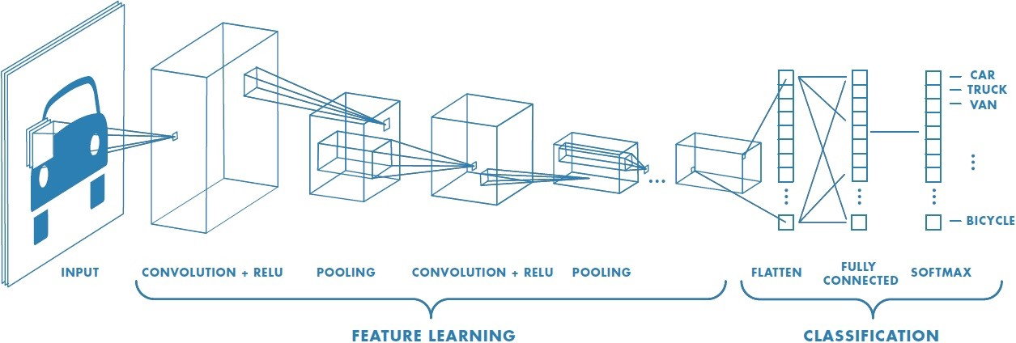

**Fig (b): CNN/ ConvoNet work follow.**

**DATASET:**

Our dataset1 consists of 70 melanoma and 100 naevus images from the digital image archive of the Department of Dermatology of the University Medical Center Groningen (UMCG) used for the development and testing of the MED-NODE system for skin cancer detection from macroscopic images.

1. <http://www.cs.rug.nl/~imaging/databases/melanoma_naevi/> (Last changed: 26-07-2015.)

**REFERENCES:**

1. Han, Seung Seog, et al. "Classification of the clinical images for benign and malignant cutaneous tumors using a deep learning algorithm." *Journal of Investigative Dermatology* 138.7 (2018): 1529-1538

2. Refianti, Rina, Achmad Benny Mutiara, and R. Poetri Priyandini. "Classification of Melanoma Skin Cancer using Convolutional Neural Network." *Int. J. of Advanced Computer Science and Applications* 10.3 (2019).

3. Jaiswar, Sanjay, Mehran Kadri, and Vaishali Gatty. "Skin Cancer Detection Using Digital Image Processing." *International Journal of Scientific Engineering and Research* 3.6 (2015): 138-140.